Course IIA2017

Industrial Information Technology

Data Communication and Digitalization Assignment

Abu Tammam Bin Nuruddin

Student ID 258955

5 February, 2023

Contents

Contents 2

1 Introduction 3

1.1 xxx 3

1.2 xxx etc 3

2 Chapter title 3

2.1 Subchapter title 3

2.1.1 Sub-subchapter title 3

3 Chapter title etc. 3

4 Conclusion 3

References 3

Appendices 3

1. **Introduction**
   1. **Student Information**

After entering the student name, number and semester year into the DataCommStudentInfo app the following information in Figure 1.1 is acquired.

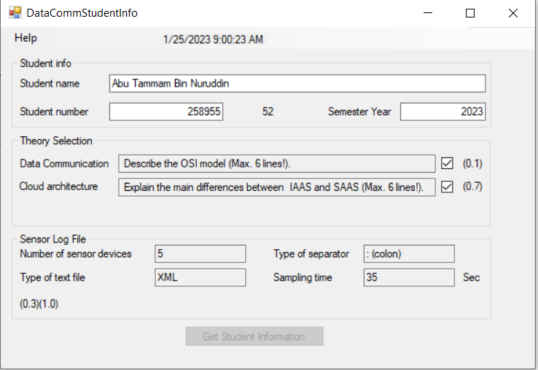

Figure 1.1 A screen shot of the Student Information in the DataCommStudentInfo application

* 1. **System Information**

1. **Network Information**
   1. **Network Description and Devices**
      1. **OSI Model**

Open System Interconnection is a reference model that describes the how the information of different applications in one node communicates to other nodes. Both

**2.2 Wireless**

1. **Network Testing**
2. **Digitalization**
3. **Cloud System**
4. **Conclusion**